**Biology, Castle View High School  
Dr. Jason R Mayberry**

**Study Guide: Intermolecular Bonds**

**Vocabulary Summary**

1. Intra-Molecular Bonds
2. Inter-Molecular Bonds
3. Hydrogen Bonds
4. Van Der Waals Forces
5. London Forces

**Conceptual Questions**

1. Compare and contrast Int**ra**molecular Bonds and Int**er**molecular Bonds.
2. What are Hydrogen Bonds? What must be true about the parts of the two molecules where they form?

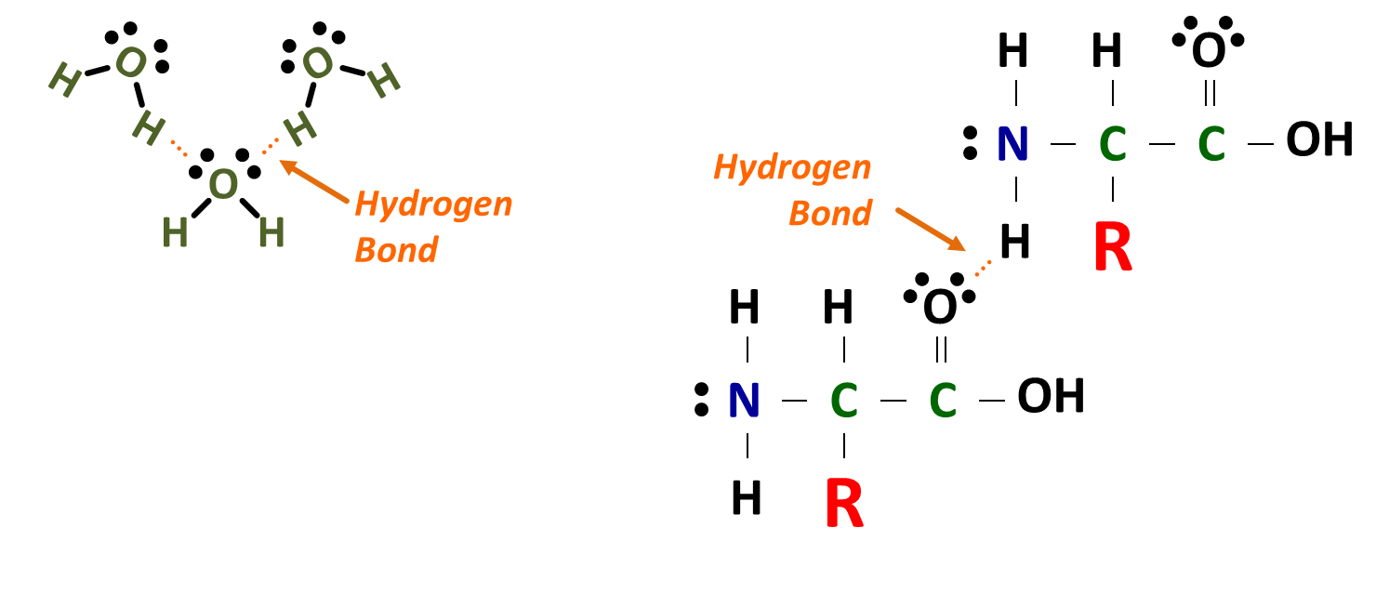

1. Describe the role of hydrogen bonds in forming and melting ice?
2. What are Van-De Waals Attractions? What must be true about the parts of the two molecules where they form?

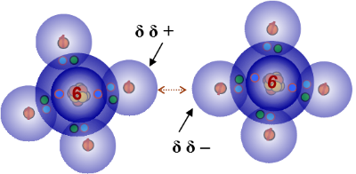

1. Where do Hydrogen Bonds and Van Der Waals interactions fit in relation to the bonding continuum of Intra-Molecular Bonds. Why?

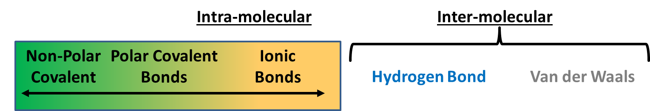

1. What is the pattern in terms of bond strength in the diagram below? Explain why this is so.